Prototype Report v1

1) Executive Summary

1.1 Purpose
The AI Failures Museum is a web-based application that presents exhibits of failures, limitations or misuses of AI-supported systems. The aim is to highlight the faults in previous AI systems and provide learning techniques such as quizzes to help educate users on how these issues arose. AI failures is a problem because as the advancement of AI is resulting it in being more prominent in everyday life, more aspects are being affected such as businesses.

1.2 Benefits
There are various different benefits that come from the development of the AI-failure museum system. Educationally, the system encourages active discussion of the importance of AI and their failures through displaying the exhibits. It raises awareness of these issues and their consequences to a wider variety of people. Also, the reflective quizzes bring the educational benefit of supporting users in their learning by testing their knowledge.
Additionally, in terms of the user experience, the intuitive browser-access application is a key benefit for allowing the users of the system to navigate the system with ease. As well as this, the exhibits page is structured and laid out clearly so users should have no issues locating these learning exhibits.
Furthermore, the modular architecture is a technical benefit of the prototype because it allowed each development team to work on their part without breaking others. This parallel development allowed for simultaneous work which sped up the development time.

1.3 Risks and Limitations
There are a number of technical elements that should be acknowledged. At this stage the system is tested to a limit; how the admin and visitor actions affect the system is the priority with more complex unit testing carried out in the next sprint. Also, increasing the dataset to include lots more exhibits may impact the performance of the web-application.
Moreover, as for the prototype there is a limited number of exhibits portrayed on the web-application which reduces the representativeness of the AI-failures. As well as this, the exhibit data for the AI-failures is manually inputted which could lead to the risk of incomplete or incorrectly assigned data and artefacts.

1.3 What the prototype does now
At the end of sprint 1, the prototype consists of the fundamental features the system requires. The web-application can be run locally and also deployed via a website. As it stands there are two main user types of the system, the visitor and the curator. The home page of the website allows the user to log in or register if they haven’t already got an account. The curators are created by the developers to avoid any user being able to possess admin permissions. Once logged in as the visitor, you can navigate and view an exhibit which takes the user to a separate page presenting all the information about the AI-failure it is representing. The visitor can also then navigate to the quizzes page where they can complete the quiz for the exhibit they just viewed. After completing the quiz, they are given a score based on how well they did in the quiz. Moreover, the curators have a separate dashboard where they can create exhibits by manually adding in all the information required to be presented.

2) Project Description and Requirements

2.1 Problem Context
With the rapid advancement in Artificial Intelligence, more domains in our world are incorporating AI-supported system into their environments. Businesses, healthcare, politics, policy, decision-making are all aspects of our world which have started to incorporate AI-supported systems, in particular environmental corporations. These systems can ultimately lead to significant societal, ethical and legal consequences if they fail and as this is an ongoing development, failures are always occurring.
AI failures are often poorly documented across news articles and reports and therefore result in difficulties for non-experts to understand the consequences. As a relatively new advancement, there is limited educational material that states clearly why AI systems have failed and how these failures have ethical or societal impacts. Therefore, this is a big motivation for our project as learning from these failures is crucial for responsible AI development and encourages the wider community to educate themselves on these issues. Hence, this project demonstrates an educational prototype as a digital museum that presents and quizzes users with AI failures as structured exhibits.

2.2 Aims and Objectives
The overall aim of the AI failures museum project is to produce and informative web-application which has the ability to raise awareness of these different instances of AI-supported systems failing and the consequences of this failure on the wider world. The quizzes are designed so that after the visitors have observed and learnt about these failures, through the exhibits, they can reflect and test their level of knowledge and understanding.
Visitors should leave our museum much more experienced with how AI systems are affecting the world socially and ethically and therefore lead to much more careful consideration when organisations are developing AI-supported systems.
A number of objectives outlined below are established to be achievable for our prototype but also allow the basic system to be produced which will be built onto in sprint 2. The first objective is to design a structured data model for the AI-failure exhibits where the data model supports the exhibits, the AI system description, the failure description, any contributing factors and the lessons learned.
Secondly, a web-application is needed to allow users to browse the selection of AI-failure exhibits, with each exhibit page including the information from the data model. Another objective is the quizzes linked to the exhibits which are intended to encourage reflective interaction and learning for the visitors of the system.
Moreover, from an ethical standpoint, another objective is to identify and therefore address any ethical or societal considerations to do with the AI-failure system. Furthermore, in terms of user interface, an objective is to design a simple and intuitive interface which allows users to navigate with ease, despite not having and technical background. Finally, the last objective for the prototype is to document accurately the system design, system architecture, the data model used in our project.

2.3 User Profiles
For our project there are 3 main users to consider, the Visitor, the Curator and the Developer. For the visitor, their role is to be the learners of the system. They are the primary users who access the web-application to browse the exhibits and view the explanations and lessons learned from each AI-failure example. The visitor demonstrates their learning through completing the short quizzes which reflect the information portrayed in the exhibits.
Additionally, the curator’s role is to be the moderators of the system. Their responsibilities involve creating and editing the exhibits, uploading the supporting artefacts for the exhibits and describing the failures and lessons for each exhibit. Their main goal is to maintain the system for the use of the visitors and ensure that the exhibits are displayed and functioning properly.
(NOT FULLY IMPLEMENTED YET) Finally, the developer’s role is to maintain the system to a presentable standard. Their responsible for accessing the source code through GitHub and running the system locally using documented steps demonstrated in the ReadMe file. They are also responsible for introducing new failure types by extending the exhibit schema.

2.4 Functional Requirements
The functional requirements for the prototype are as followed:
- Visitors can register an account and all users (including curators) can login
- Visitors can navigate the front end and view exhibits, individual exhibit pages and the quiz for the exhibit.
- Quiz with multiple choice questions where visitors can fill out and be returned with their score
- Curators can create exhibits through a separate dashboard, as well as edit existing exhibits
- The system can be deployed and ran via a web browser

2.5 Non-Functional Requirements
The non-functional requirements for the prototype are as followed:
- The interface should be simple to navigate and a new user should be able to locate and view different exhibits and quizzes
- Traversing between different pages on the website should take place in an acceptable time when adding information such as login credentials or clicking a button
- The system should be accessible via a web browser
- User passwords should be validated and stored securely and curator permissions should only be granted to curators to by the developers
- The modular architecture should provide the ability to change/update different sections of the system without breaking other parts

2.6 Success Criteria
- The core features of the system are working correctly and a visitor can register to the system, view an exhibit, view a quiz for that exhibit, complete the quiz and receive a score for the quiz accuracy without any errors.
- A curator can successfully create an exhibit, add all the information to the related fields and produce a quiz associated with the exhibit.
- Authentication is working accurately when registering an account and attempting to login and passwords are validated to ensure security.
- The user interface of the system is clear and tidy and presents a professional identity for credibility as a learning platform.

3) System Architecture

3.1 Architecture Overview
The system was created using the Django framework in Python and this allowed us to create the web-based application which presents the exhibits. Django was a clear choice for its rapid-development and suitability for database-driven applications. As our system required the storage of a large number of exhibits and quizzes it seemed like an effective choice. The architecture of this system follows a client-server format where users can interact with the application through a browser-based interface.
Our system can be running locally or deployed through utilising PythonAnywhere. It’s a cloud-based hosting platform that provides strong compatibility with Django and our SQLite database. The server on PythonAnywhere was used to clone the repository on GitHub which allows for easy updates by simply pulling the latest version from the active development branch. A virtual environment was used to handle all dependencies required for the system and a requirements.txt file was created in order to install them onto the server. Furthermore, in settings.py in the project DEBUG was set to false on the server side to prevent any security issues such as potential attacker leaning about vulnerabilities through the debugging information displayed. In addition, ALLOWED_HOSTS was configured to include the domain name for the cloud-based server used to deploy the system and ensuring secure request handling. Once configured the system was operational and deployed at the domain name: bigleh.eu.pythonanywhere.com

3.2 Component Diagram
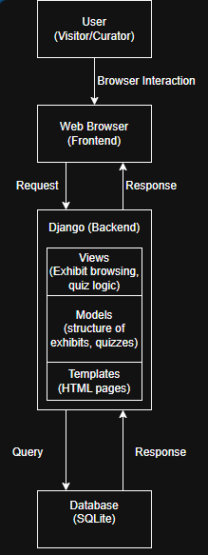

- User (Visitor/Curator): Visitors access the system by registering an account and logging in. Curators have accounts created for them by the developers. Visitors browse the exhibits and take quizzes whereas curators have admin permissions which allow them to create and manage exhibits.
- Web Browser (Frontend): Renders the HTML templates that Django sends back and presents the interfaces for the users of the system.
- Django (Backend and API): provides API endpoints to processes incoming requests from the web browser and interact with the database in a secure and controlled manner. Views is where the logic for these API endpoints is defined. Models is where the data structure for exhibits, quizzes etc are defined. Finally, templates generate the HTML for the browser to display the interfaces.
- Database (SQLite): Stores the data for the exhibits, quizzes, user accounts etc.

4) Data Model and Dataset Description

4.1 Data Model Description
An initial version of the data model was established in the early stages of development. This version aimed at capturing the main entities of the system, including exhibits, failures, contributing factors and lessons learned. Each exhibit is a single case study used to describe an AI system, their use and the failure as a result. The focus for this early version is to ensure the required attributes and relationships were demonstrated in a way which allowed the development team to create the backend of the system with an idea of what these looked like. Following this initial version, the data model was reviewed by the team and refined by the data modelling lead. Relationships were simplified, naming conventions were aligned and the overall consistency with the system logic was improved. This development ensured all required exhibit data could still be represented.
As represented in the UML diagram below, the main entities include:
- Exhibits: represents the exhibits being stored in the AI museum
- Artefacts: represents the evidence that an exhibit entry would be based on
- Ai_system_description: represents a section of information that describes the overall system for an exhibit
- Failure_description: represents a section of information that describes the failure of AI for an exhibit
- Lessons_learned: represents a section of information that describes what not to do in the future for an exhibit
- Contributing_factors: represents a section of information that describes what key factors led to the AI failure for an exhibit
- Book_marks: used to link exhibits and users so that users can keep track of exhibits they have viewed and interacted with
- quiz: represents the quiz for each exhibit
- question: represents each individual question in the quiz
- answer: represents an answer to each question
- result: used to represent a quiz attempt by a user

UML Diagram
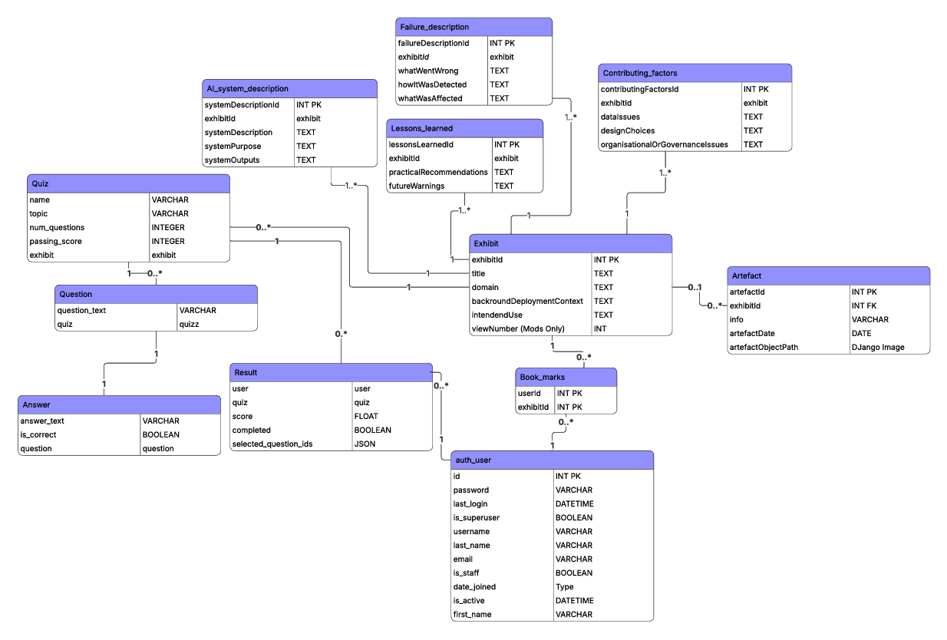

4.2 Passport Schema
- Product: Each exhibit represents the main product being examined and the ai_system_description entity is where the information about the AI system is stored.
- Nodes: The contributing elements within the system include the contributing_factors entity which holds the key, related components that motivated the AI-failures occurrence.
- Stages: The stages of the AI system lifecycle are illustrated in the ai_system_descrption and failure_description entities which outline the development, deployment and failure occurrence for the exhibit.
- Evidence: Entities such as artefacts, lessons_learned is where evidence is implemented. Also, the quiz, question, answer, result entities further support interactive evidence-based learning and reinforce the engagement needed with this topic to reflect and understand.

4.3 Dataset Structure and Generation
For the prototype v1, the system currently has one fully implemented AI failure exhibits which is used to show the functionality and structure of our web-application. This example is stored on the system as an exhibit entity and is related to the following associated entities:
- ai_system_description
- failure_description
- lessons_learned
- contributing_factors
- artefacts
The data for the example of the AI-failure system was manually gathered from public sources such as credited news websites and articles and structured according to the relational schema shown in the UML diagram. Despite the prototype only containing one exhibit, the structure of the database and API design allows for multiple exhibits to be added in the next sprint. Therefore, the system is scalable and expandable due to its structure.

5) Evaluation Plan (Initial)

5.1 Early Results
In order to test the current version of the system, structured API and authentication testing was developed. Test data was created before each test to check that the parts of the system being tested could be tested accurately.
API Testing:
Exhibit API tested for:
- Retrieved all exhibits
- Retrieving a single exhibit
- Retrieving a non-existent exhibit
- Creating a new exhibit
- Updating an exhibit
- Deleting an exhibit
The results demonstrated that the functionality of the exhibits work correctly.
Artefact API tested for:
- Creating a new artefact
- Creating an artefact with a non-existent exhibit
- Retrieving an artefact
- Updating an artefact
- Deleting an artefact
The results here showed that our system enforces referential integrity as it prevents artefacts being linked to exhibits which are invalid.
In addition, other APIs such as System Description, Failure Description, Lessons Learned and Contributing Factors were tested similarly. These were tested for creation, retrieval, updating and deletion where needed for each API.
When all tests passed this output in the terminal is presented:
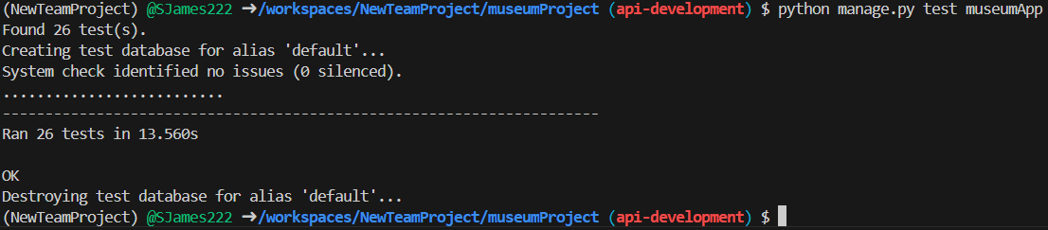
Authentication Tests that:
- Unauthenticated GET requests are rejected
- Unauthenticated POST requests are rejected
- Authenticated curator GET requests succeed
- Authenticated non-curator users are denied
- Logging out prevents access
These results show that the access control restraints function within the system as intended to.

5.2 Next Steps
Moving onto the second sprint, there are a couple of aspects which need to be addressed to improve the prototype system. Firstly, images will be implemented for the artefacts and the dataset will be increased to present more exhibits which portray different examples of AI-failures. There will be more exhibits showing different failures and the reasons for their failures. This will show a more representative dataset which demonstrates a wider variety of instances. Navigation features such as searching for exhibits by category and title will also be implemented.
In addition, curator tools for quizzes will be developed, allowing the curators to create, edit and delete quizzes as well as implementing an analytics dashboard, which lets the curators see average scores for quizzes, and other useful analytical information. A pass/fail mechanism will also be implemented into the quizzes, allowing the users to retake quizzes if they score below a pre-defined threshold. The quizzes for the exhibits will be moved and linked directly with the exhibits they are reflecting. As it stands, the quiz is located separately to the exhibit it is testing. For the next sprint the aim is to link the two so they are more accessible. Finally, during sprint 2 there will be additional testing implemented such as user acceptance testing and improved unit testing to ensure that all the features of the system are functioning accurately.
Several security and performance enhancing features will also be implemented, such as pagination for list views (such as viewing all exhibits or all quizzes). Another measure is implementing throttling or rate limiting on the API end points, in order to protect against Denial of Service attacks and general high traffic. End points will also be tested for other vulnerabilities such as injections, and further data validation may need to be implemented within the end points.

6) Risk Register
The full risk register is located in the ELE zip under the folder 3_process/risk_register.

7) Project Management and Team Process

7.1 Team Roles and Responsibilities
Project Lead = Dom
Technical Lead = Alex
Software Developer = Leo
Data/ML Lead = Jimi
UI Designer = Coco
Testing & DevOps = Sam
Documentation = Dylan
Task | Project Lead | Tech Lead | Software Dev | Data/ML Lead | UI Designer | Testing & DevOps | Documentation
Project planning & scope | A | C | I | C | C | I | R
Requirement’s analysis | A | C | C | C | C | I | R
System architecture design | C | A/R | C | C | I | C | I
UI design | C | C | I | I | A/R | I | C
Database development | I | R | R | A | I | C | I
Software development | I | A | R | C | I | C | I
Testing | I | C | C | C | I | A/R | I
Evaluations & results | A | C | C | R | I | C | I
Documentation & report | C | I | I | I | I | I | A/R

